Business handover

Following the successful merger of the companies Büro Schoch direct AG and Vögtli Bürotechnik AG over the last year to form Schoch Vögtli AG, Andy Vögtli is transferring his share of the company to Thomas Schoch, who will therefore now hold 100% of the company's shares.
"Due to the company's good starting position and stronger position within the market, last spring I had already decided that I was going to withdraw from the operational management of the company. The handover of my shares to CEO and co-owner Thomas Schoch is the next logical step as part of the merger," says Andy Vögtli, and continues: "I would like to wish the employees, the company and Thomas Schoch all the best and every success over the coming years, and I will continue to maintain a friendly relationship with the company, providing advice where needed. After working in the office supplies and equipment sector for 37 years, I am looking forward to my next professional venture – the further development of the independent company Vögtli Büro Design AG.” He would also like to especially thank the customers, partners and suppliers for the long-term business relationships.
Thomas Schoch thanks Andy Vögtli for the handover: "With a great deal of skill, Andy Vögtli successfully managed and developed Vögtli Bürotechnik AG for 37 years. He shared his vision of the merger and played a considerable part in its success. I would like to thank him for his commitment and cooperative partnership." Thomas Schoch goes on to say that despite the departure of Andy Vögtli, the company will continue to pursue the sound values of a Swiss family company as well as the current strategy, with the company's locations remaining vital to its purpose: "In the economic centres of Basel and Zurich, where our employees are based, we want to be able to offer customers quick, professional and solution-oriented advice. All this, of course, carried out in line with our guiding principle that Schoch Vögtli 'makes it easy.'“
Schoch Vögtli AG employs around 100 members of staff at the Basel, Ober-Ohringen and Aarburg locations and generates annual sales of CHF 36 million through the sale of office and school supplies.

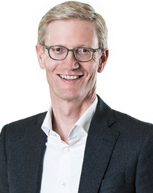  Thomas Schoch | 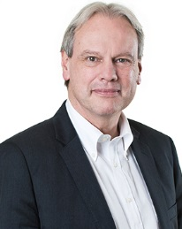  Andy Vögtli

